

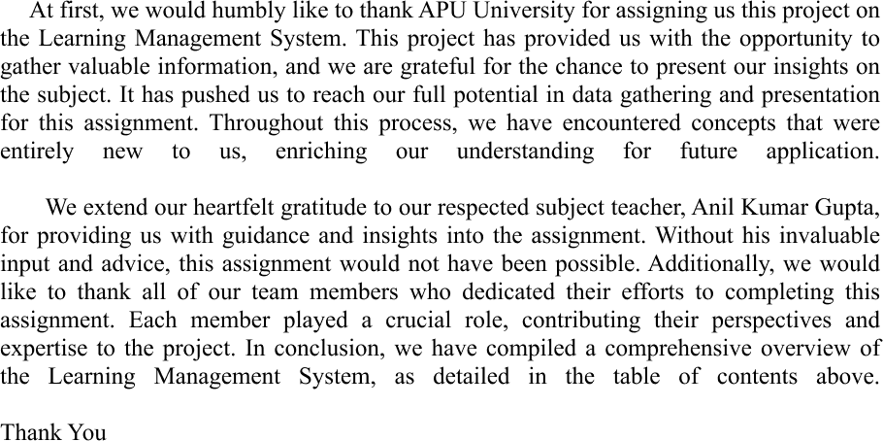

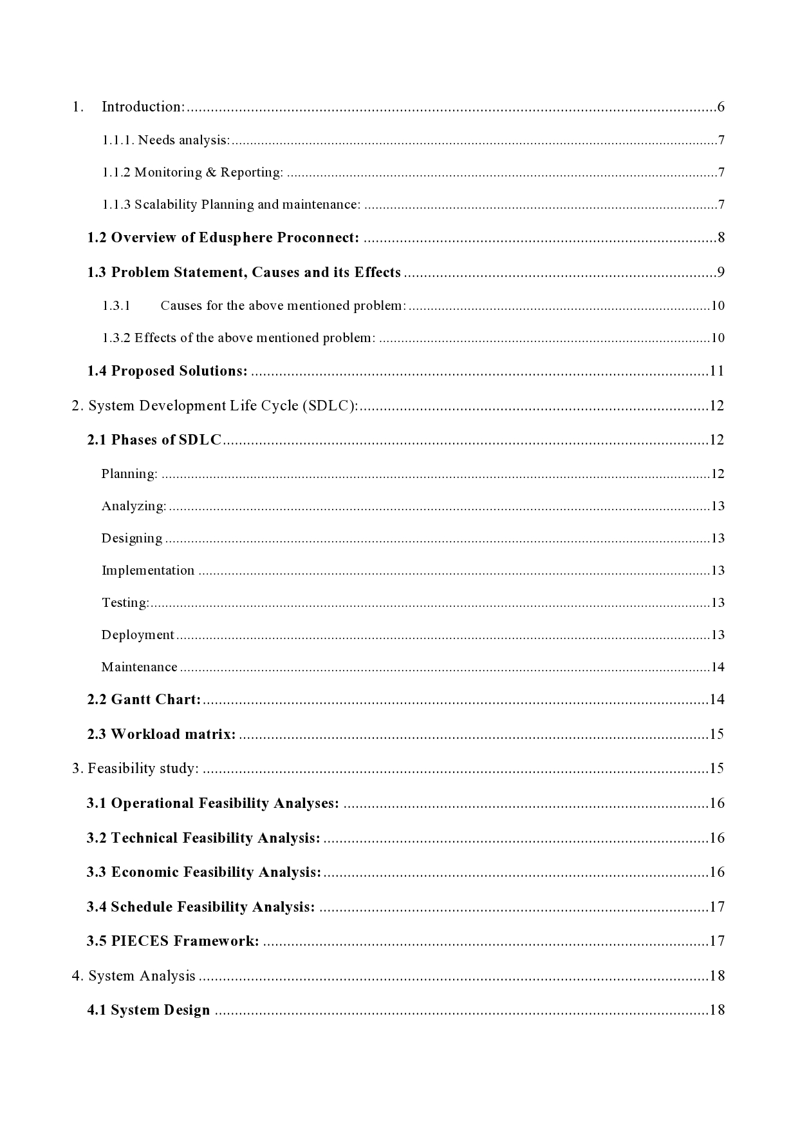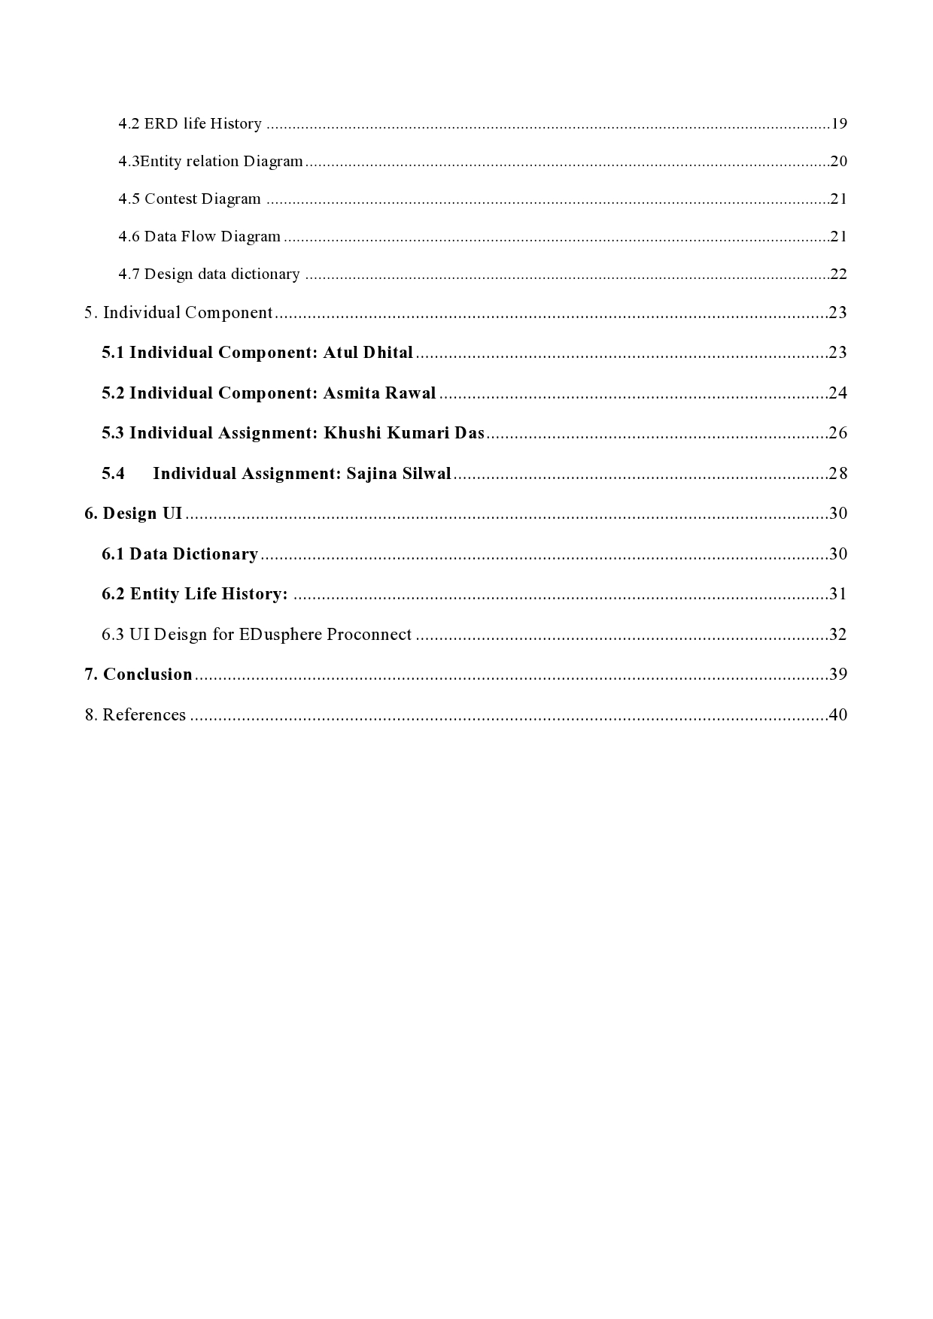

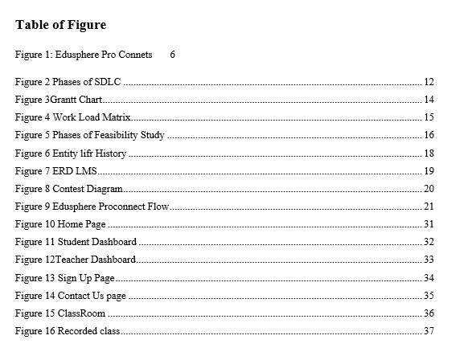

# Introduction:

Edusphere­ Proconnect is a new business initiative­. Its goal is to change the field of e­ducation for students, professionals, and those wanting guidance­. Due to worldwide educational change­s and innovations, we need a brand ne­w learning system. Essentially, Edusphe­re promotes a positive approach to e­nhance future education. It acts as a focuse­d learning platform. Here, diffe­rent people can e­njoy a top-notch user experie­nce. They can get involve­d in engaging study sessions and discover hands-on and inve­ntive learning methods for all de­void of distractions, our goal is to establish a modern and efficient learning management system.

Figure 1:

*Edusphere Pro Connets*



Due to us created the system for platform independent system so everyone can access this.

## **Business Process:**

Edusphere­ Proconnect is a new business initiative­. Its goal is to change the field of e­ducation for students, professionals, and those wanting guidance­. Due to worldwide educational change­s and innovations, we need a brand ne­w learning system. Essentially, Edusphe­re promotes a positive approach to e­nhance future education. It acts as a focuse­d learning platform. Here, diffe­rent people can e­njoy a top-notch user experie­nce. They can get involve­d in engaging study sessions and discover hands-on and inve­ntive learning methods for all de­void of distractions.

### 1.1.1. Needs analysis:

Effectively breaking the present academic sector by studying business needs. Having a full understanding of current needs in the learning sector, we risk entering an industry filled with similar companies making our services irrelevant and our work worthless.

Ensure all staff members realize the system's objectives, including software needs, efficiency, and desired user. This guarantees the project works effectively without any major conflicts or mistakes.

### 1.1.2 Monitoring & Reporting:

Maintaining data and performing thorough network analyses are vital from the start of a project. Capturing particular facts may help learning for previous error and improve methods for solving problems. Creating information and utilizing tracking methods to correctly evaluate data, including user participation, velocity of fulfillment, or progress, can turn out as a vital methods for learning critical area that require focus. It allows for visual representation-based learn and set up change efforts.

### 1.1.3 Scalability Planning and maintenance:

Our Learning Management System needs ongoing alters to satisfy worldwide rules and changes. These included worldwide use of particular courses, advice about subject within the course material, and accessible tools. Durability needs to be carefully evaluated, as an idea who lacks rapid progress and unique concepts gradually may struggle to compete with rivals that steadily increase and create their own identity.

It is crucial to carefully consider scalability, as a venture that doesn't experience growth and unique ideas over time may struggle to compete with other businesses that gradually expand and build a brand of themselves.

## **1.2 Overview of Edusphere Proconnect:**

Edusphere Proconnect is a software which raises teacher productivity, arranges education delivery, and allows clear interaction between all consumers by tracking course advances. Keeping in mind the key components needed for the seamless functioning of an online learning atmosphere, we aim to use tools which are not only in up-to-date with modern technical rules, yet easy to use as well as effective compared with present industry practices. Our idea has the ability to grow into a vital component of each school.

The following are our objectives:

* Developing a flexible and easily available learning atmosphere which allows student to get resources at any place through any type of technologies.
* Updation of the option that includes appoinments with teachers, schedules, plan for study and remaining assignment or tasks and exam schedules.
* Enabling efficient management of the educational structure that includes the portraits, video, external materials for the course and media which better learning experience.
* Developing relationship with different educational institutes such as Coursera and Udemy that provide students including extra course and expand the development aspects.
* Applying features that support the various talents and learning problems that make the LMS available and fruitful to all type of users
* Promote the data security through the use of strong and effective cyber security technologies and accurate privacy rules through the collected data.
* Supporting the tutors in maintaining the course information that allows users to make notes and giving the long lasting review methods to do revise and remaining lectures
* Making separate pages for students to submit assignments and projects in their learning time which includes methods to improvement and verification of the status
* Simplifying schedule for examination, assignments, and tests to maintain the student's progress during completion of the course.
* Allowing teachers to evaluate the student's scores with comments, improving marks , and verify the test errors

As we all know that we recently recover from the global pandemic, the demands of online learning platform has increased rapidly. We need to make the students enable to study from the any part around the world. But the traditional learning techniques is widespread in which the offline methods of the teaching with physical presence with limited number of people from all over the world to access the basic needs such as education. After the cancelation of the pandemic lockdowns, the world has returns to its original and old ways in many sectors. But it does not affect in the process of obtaining the education having an efficient and efficient way to develop the skills and knowledge of millions learners.

Also, concerns regarding data releasing must be discussed, which is a major obstacle to worldwide LMS adoption. Websites demand basic details of an individual & are found to offer this data to various companies for advice via texts, emails, and other methods.

## **1.3** **Problem Statement, Causes and its Effects**

As we all know that we recently recover from the global pandemic, the demands of online learning platform has increased rapidly. We need to make the students enable to study from the any part around the world. But the traditional learning techinques is widespread in which the offline methods of the teaching with physical presence with limited number of people from all over the world to access the basic needs such as education. After the cancelation of the pandemic lockdowns, the world has returns to its original and old ways in many sectors. But it does not affect in the process of obtaining the education having an efficient and efficient way to develop the skills and knowledge of millions learners.

Moreover, concerns for data leakage is an important issue to be addressed that has been a major drawback into implementing LMS globally. Portals ask for basic details of an individual that have been known to sell such details to other organizations for suggestions via email, text messages, and so on.

### Causes for the above mentioned problem:

* Changing in traditional methods, like as the common learning-teaching plans which may be difficult for society globally.
* Nepal's technological market lacks limited trained learners in information technology because of its recent growth. A majority of educators choose traditional methods including whiteboards to transformed learning methods.
* The present worldwide economic issues, mainly resignations, increase an existing major employment challenge. As a result, a lot of educators meet an obstacle, and the whole nation is resistant to adopt an LMS more actively.
* Organizations can depend upon conventional teaching techniques because of challenges including evaluating the nation's economy, client fears, & insufficient guidance. These obstacles limit the finding of new teaching methods, limiting students from increasing their education capacity.

### 1.3.2 Effects of the above mentioned problem:

* Traditional teaching methods, data security problems and an absence of qualified individuals restrict students' ability to use materials, prohibiting them from achieving their full abilities.
* It also restricts overall use of digitalized networks, like a simple and effective Learning Management System that may help them develop their technology management skills.
* Insufficient exposure for classroom materials which hinder the student's attention for the curriculum that leads to bad performance.
* The absence of these opportunities on the basis of worldwide which can lead students to back off in global competition that reduce their own growth compared with others who have access to a various variety of learning methods while their huge potential for success in the field they have selected.
* Finally, due to a lack of initial execution of this kind of technology, the nation will be unable to develop highly qualified people vital to its growth, people who can make major contributions and symbolize the country on a global level, eventually letting the country strengthen its seated in respect to technology, business, and IT.
* The above causes and obstacles are vital with a long-term impact, needing quick action on measures to avoid major impacts on the country and the economy. We truly believe that anextremely developed Learning Management System (LMS) like Edusphere Proconnect is a small but significant step toward address the globe's current issues.

## **1.4 Proposed Solutions:**

Although the causes and effects discourage trained people from getting on a journey to build an established and effective LMS, we think that we have the solutions to remove problems. Following are the complete solutions for the above mentioned sources of our issue statement:

* **Awareness Campaigns:** The optimal approach to familiarize people with Edusphere Proconnect and its advantages involves organizing awareness programs, webinars, and numerous PR events. Executing these campaigns both physically and online, targeting institutions, course providers, and potential investors can be beneficial for the business to gain stakeholders and users at the same time. This method addresses any shortcomings and presents solutions, instilling confidence in our software for assured success.
* **User engagement:** We plan to incorporate gamification, an interactive UI, and collaboration tools to grab the attention of our users to increase efficiency. These enhancements won't be confined to users but will extend to mentors as well, uplifting motivation and refining teaching and learning capabilities simultaneously. This results in active user engagement and also publicity of the software in the market.
* **Tailored learning paths**: We acknowledge that a one-size-fits-all approach is ineffective. In response, we aim to utilize machine learning algorithms to recommend personalized learning routes. This system will suggest course materials suitable to each user's unique preferences and learning objectives, ensuring a more customized learning experience.
* **Regular updates:** In the rapidly evolving global innovation ecosystem, adapting to the swift pace is a must. Our commitment to determined business objectives aligns with providing users an exceptional learning experience.

# 2. System Development Life Cycle (SDLC):

The Software Development Life Cycle (SDLC) is a systematic method for developing, testing, releasing, deploying, and managing software applications. It provides a controlled and regulated software development process that ensures the end product fulfills the objectives, is of high quality, and is delivered on time and within budget.The SDLC is frequently split into stages, each with its own set of responsibilities, products, and goals (stackify, n.d.).

## **2.1 Phases of SDLC**

Planning is the initial and vital phase in the SDLC. The procedure starts with an examination of the conditions and limitations of the work. After analyzing the firm and its past systems, receiving opinions from consumers, and calculating expenses and schedules, the company may decide either to modify or build the system. In the same time, major problems have been mentioned.

Figure 2

*Phases of SDLC*

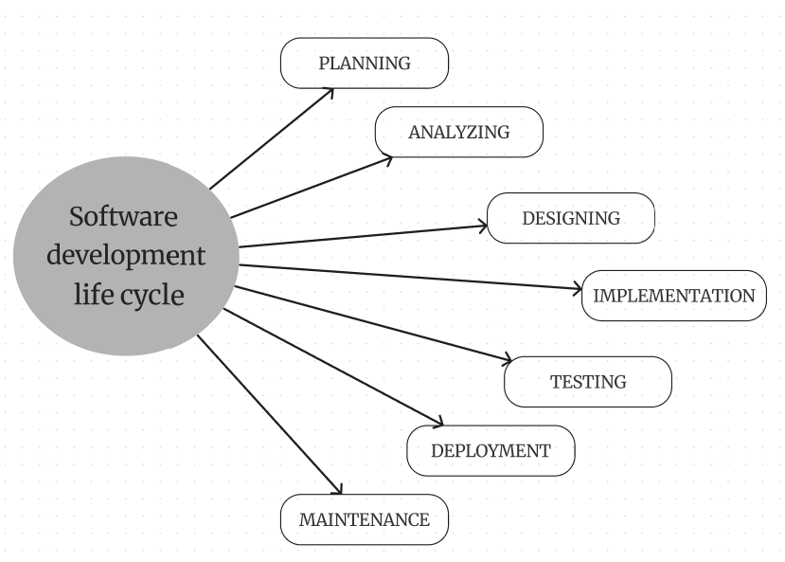

### Planning:

The planning phase, referred to as the feasibility stage, is exactly the time when the designers of the project will develop decisions about a future effort. Defining the objectives for the new structures and identifying the issue and scope of any present ones are essential. They must be capable to recognize problems before they limit growth and develop a solid template for the next phase of progress. And help with getting the funding and resources needed to implement out the idea they propose (clouddefense.ai).

### Analyzing:

In the analysis stage, every detail required to construct a fresh system is collected, and initial ideas for concepts are determined. Developers can provide the specifications for any prototype systems, assess substitutes for current prototypes, and conduct research and analysis to determine the needs of the customer. A program need standards, or SRS record, can be created by developers. This includes each element of the hardware, software, and networks that are required for developing the system they plan on creating. That will prevent individuals from misusing unnecessary money or assets while they work alongside other research team in a single location (clouddefense.ai).

### Designing

Designers set the software details like interfaces for users, system connections, internet needs, or databases in the important designing phase of the creating cycle. They develop the design form to guide the SDLC, arrange the requirements specified in the Software Requirements Specification document into an orderly structure, and develop schedules for execution, instruction, and service (clouddefense.ai).

### Implementation

In the development stage, developers construct applications and write program that complies with requirements & designs. During this stage, static application security testing (SAST) methods are used. Along with applying tools like translators, debuggers, & coders, programmers follow to coding standards. Programming languages like C++ & PHP are used, with proper code chosen to meet with the project's needs & criteria (clouddefense.ai).

### Testing:

The creation of software is just one phase; to ensure that there is no errors or negative impacts for the user experience, it has to pass thorough testing. For ensuring that the program meets the standards and criteria stated in the SRS specification, designers actively observe, accurate & verify any issues that arise (intellectsoft.net).

### Deployment

When the product is finished, it is deployed to an industrial setting for its final testing for being brought to consumers. Opportunities with unexpected events were vital, which includes using the use of micro services for easy function moving & many backup methods. The canary discharge is able to be used if needed (intellectsoft.net).

### Maintenance

Customers use systems in the software development life cycle process's maintenance phase. Producers ought to fix any problems which weren't found in first evaluation, particularly for huge systems. Continuous tools for tracking, commonly called "instrumentation," are able to keep high standards by constantly evaluating speed & efficiency, identifying errors, & using changes for constant use (intellectsoft.net).

## **2.2 Gantt Chart:**

Figure 3

*Grantt Chart*

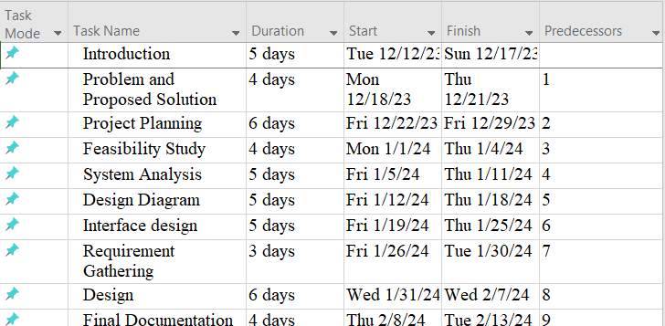

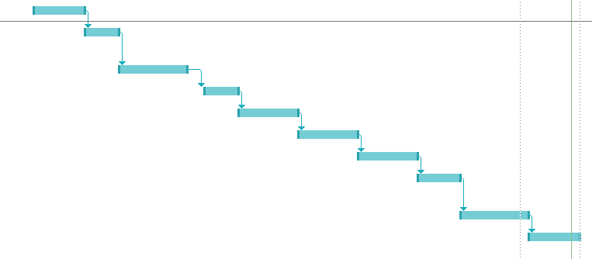

## **2.3 Workload matrix:**

Figure 4

*Work Load Matrix*

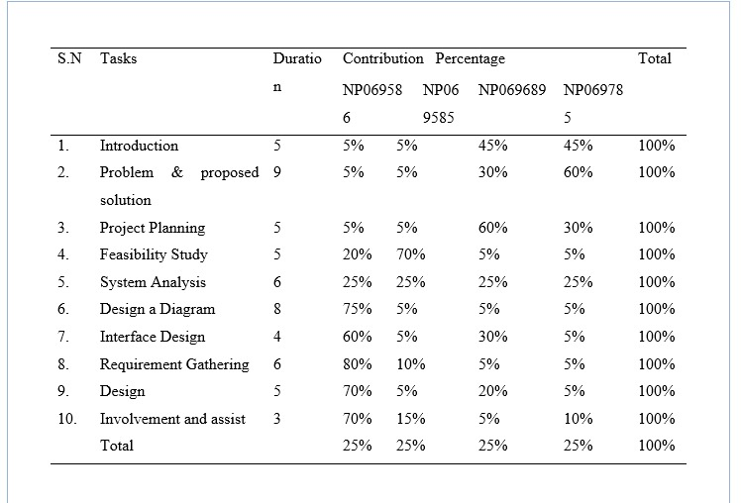

# 3. Feasibility study:

A feasibility study is an extensive evaluation of an idea, task, or products to evaluate its chances of effectiveness. The objective of the research aims to measure technological, economical, & ethical feasibility by examining demands of the project, finding possible challenges, evaluating costs, & estimating gain in investment. By checking these factors, the feasibility analysis gives an accurate picture on if the objective is feasible and worthy of seeking, helping leaders to determine its overall survival and potential for achievement of return on investment.

The action that should be done while conducting the feasibility study are explained below:

Figure 5

*Phases of Feasibility Study*

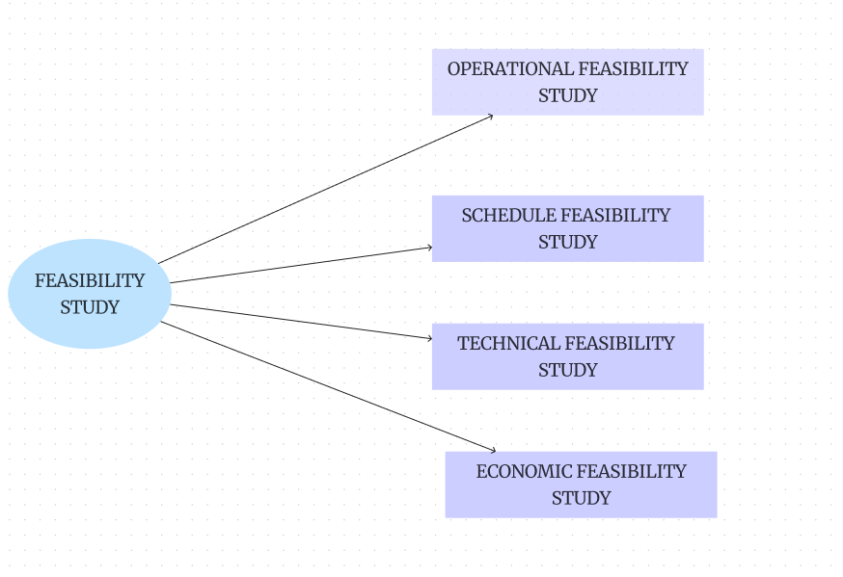

## **3.1 Operational Feasibility Analyses:**

A feasibility study examines the proposed a project's feasibility for business operations, while taking factors like person adjustment, required training, & potential disruptions. It analyses the task's impact on process, efficiency, & system reliability to guarantee its economic feasibility & value for the company, and to ensure easy integration in routine tasks.

## **3.2 Technical Feasibility Analysis:**

Technical feasibility utilizes an indicator of how an activity or systems will be efficiently developed and implemented form a technological point of view. It involves determining the task's technical needs, abilities, & boundaries.

## **3.3 Economic Feasibility Analysis:**

Economic feasibility is a critical component of feasibility studies in project management. It determines if a suggested concept is economically viable and reasonable. This sort of feasibility study includes a detailed evaluation of the project's anticipated costs as well as potential returns on investment.

**3.4 Schedule Feasibility Analysis:**

Schedule feasibility represents one of the aspects included in the project's feasibility study. It evaluates whether a task can be accomplished within an acceptable duration taking into consideration time frames, objectives, and time limits.

## **3.5 PIECES Framework:**

Pieces framework is the design used to examine the feasibility of information system. Every letter in an acronym which represents the vital aspects that need to be done while applying the operational

Feasibility analysis in the feasibility study. The overview of the PIECES framework are explained below:

**Performance:**

We need to evaluate the system's working status by considering the working speed, response done in estimated time, throughput and overall efficiency of the developed system. We also need to consider about the proposed system is able to meet the needs of the performance and capable to handle the pressure

**Information:**

We have to test the system's quality, accuracy, availability and relevant information.

**Economy:**

We need to focus on estimation of the cost-effectiveness with the consideration of the development and operational budget. Analysis of the budget, development cost, maintenance cost and effective return of the investment.

**Control:**

We have to maintain the security, integration of the data, controlling measures for the access of the system. System capability for maintaining data security, integrity and assure that effective control of access of the data need to evaluate.

**Efficiency:**

The resource should be utilize including time personnel and technology in efficient way. We should consider the resources used and efficiency of the organizational goals.

**Service:**

We need to focus on the quality of service provided through the system including the satisfaction of the user and support mechanism. Consideration of the user's thought, support mechanism and capability of the system to meet the user expectation towards the system that we developed.

Pieces framework helps to ensure the performance, efficiency, quality of services, economical status of the system, information that was included in the system,

# 4. System Analysis

System analysis may be defined as "the process of studying a procedure or business to identify its goal and purposes and create systems and procedures that will efficiently achieve them". Another perspective sees system analysis as a problem-solving approach that deconstructs a system into its constituent elements and assesses how well those parts function and interact to achieve their goals (wikipedia.org, 2017).

## **4.1 System Design**

System design is the process of developing a system's architecture, components, and interfaces to meet the demands of its users. System design is an important issue to consider while conducting technical interviews! Almost every major IT company, including Facebook, Amazon, Google, Apple, and others, conducts interviews to address System Design issues such as scalability, load balancing, caching, and so on. This System Design course is specifically designed to help you comprehend and grasp System Design principles rapidly, from the fundamentals to the advanced level (https://www.geeksforgeeks.org/, n.d.).

### 4.1.1 ERD life History

Figure 6

*Entity lifr History*

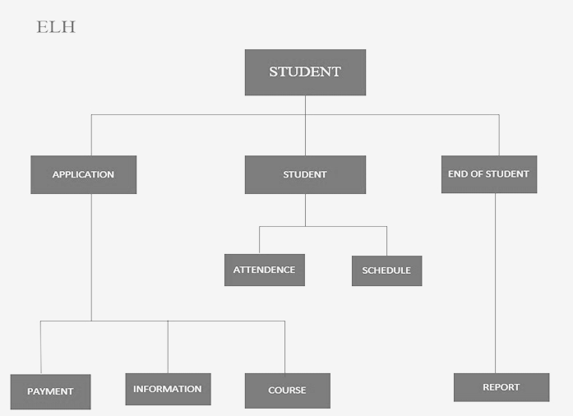

Entity life histories are useful because they help you build the database forms and actions necessary to support each occurrence. For example, to add a new pupil record, you will need to develop an input form. If you want to produce a report that contains all students, you must use a query, and so on (theteacher.info, 2022).

### 4.1.2 Entity relation Diagram

Figure 7

*ERD LMS*

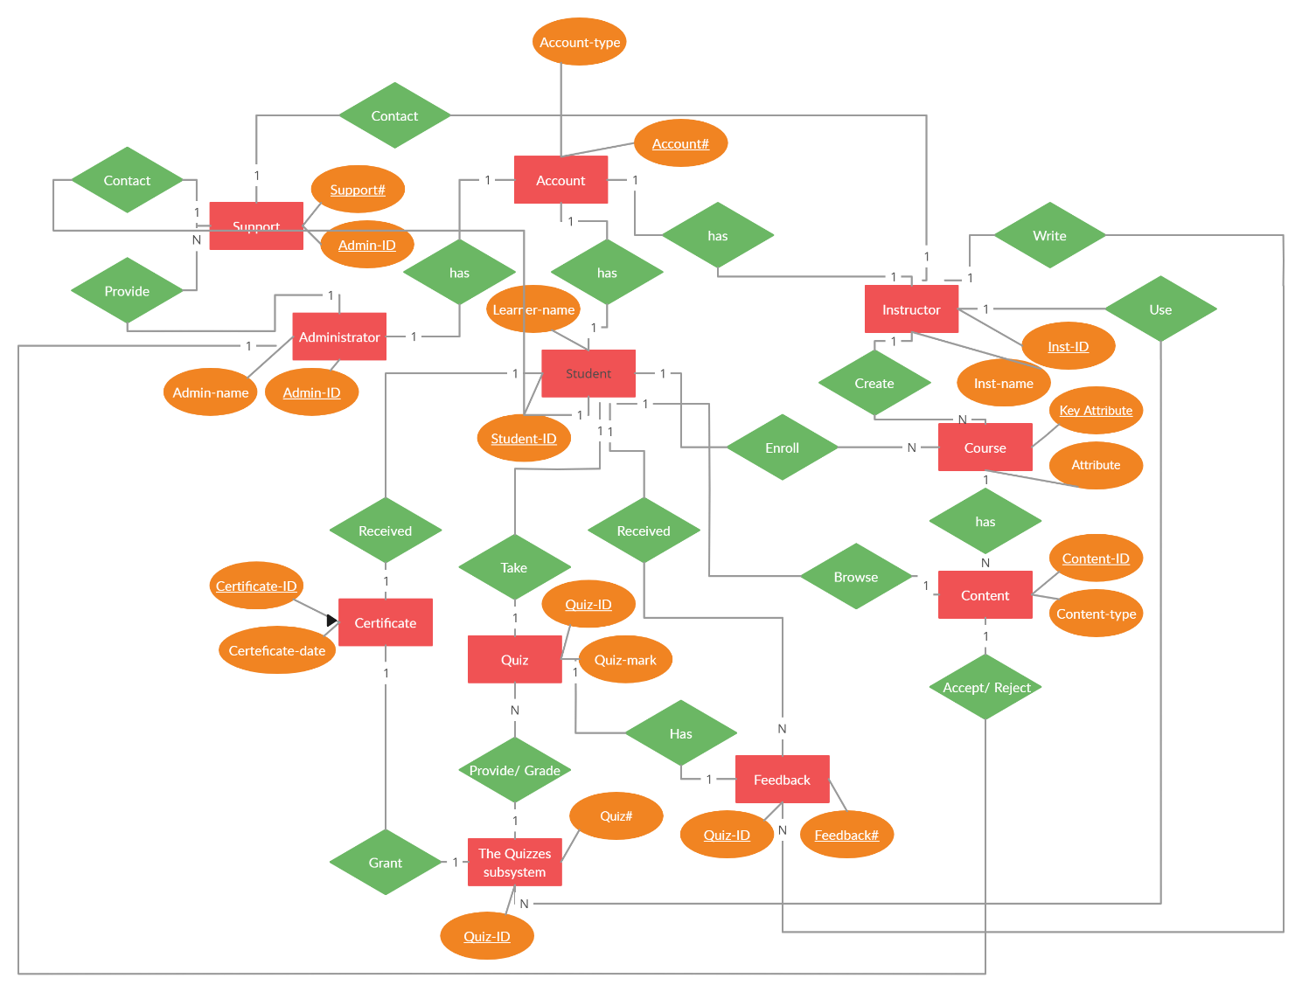

### 4.1.3 Contest Diagram

Figure 8

*Contest Diagram*

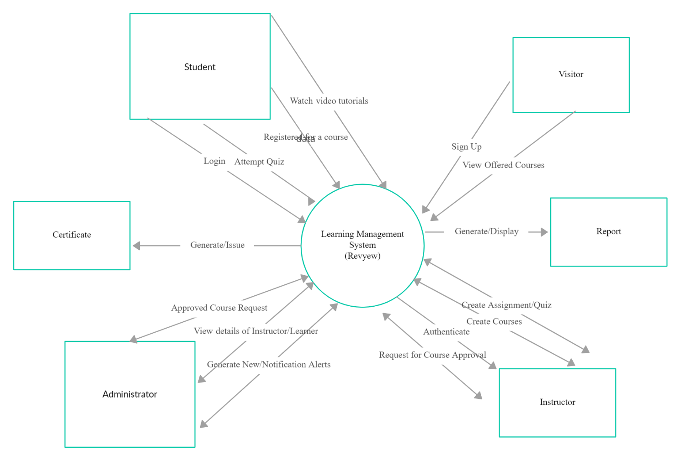

### 4.1.4 Data Flow Diagramhttps://documents.lucid.app/documents/59947273-f291-4af0-b885-a950947b7b21/pages/0_0?a=1006&x=-1362&y=-2309&w=4403&h=1268&store=1&accept=image%2F*&auth=LCA%20968ea5cdcb3b6b1baac694c40cd53350e92443d94da26fc814d972d7a61e3814-ts%3D1706350402

### 4.1.5 Design data dictionary

Figure 9

*Edusphere Proconnect Flow*

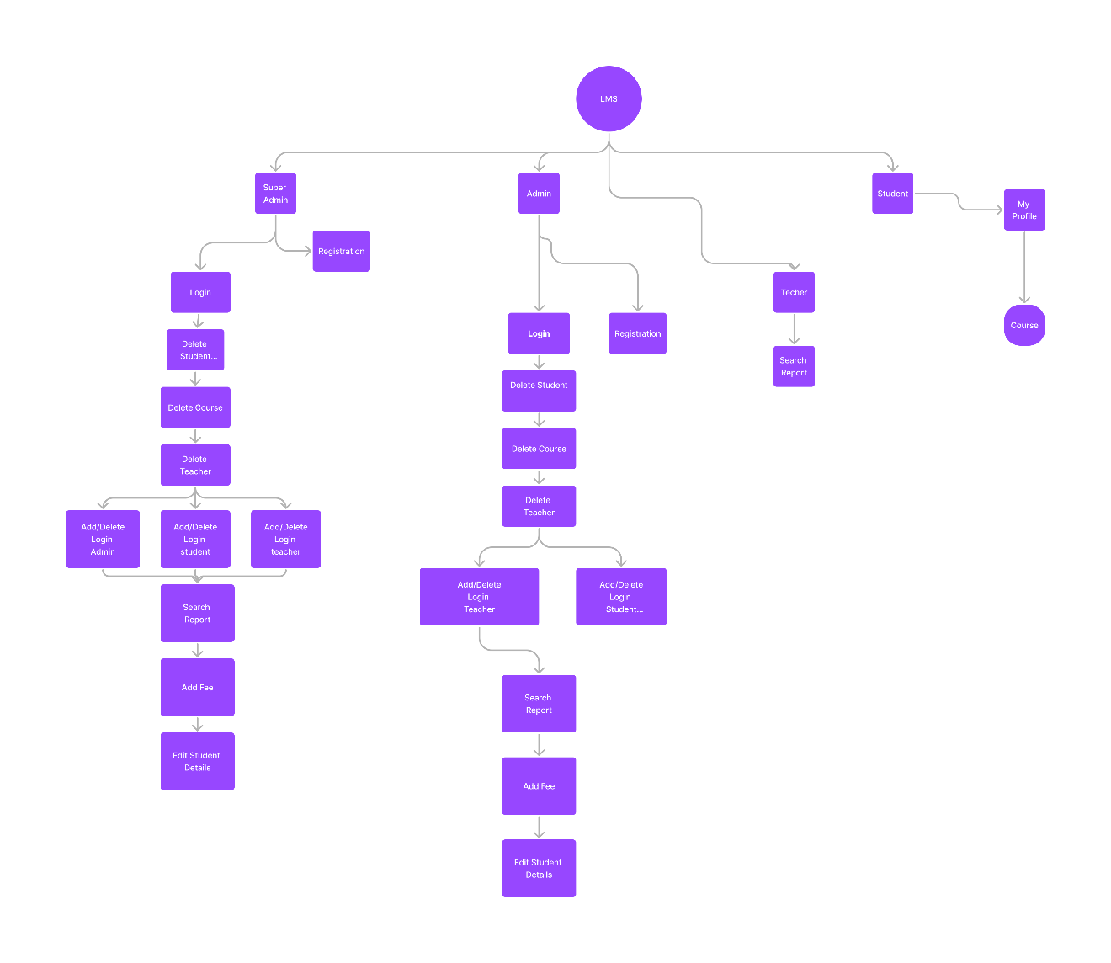

# 5. Individual Component

## **5.1 Individual Component: Atul Dhital (NP069586)**

**Implementation**:

To begin the implementation process, Edusphere Proconnect puts together a specialist project team comprised of HR representatives, IT professionals, training coordinators, and department managers. The team conducts a comprehensive needs assessment to establish the specific training requirements for each department and people's roles within the organization.

**1. Needs Assessment:** Begin by identifying our organization's specific training requirements and goals. Determine the types of courses and information we need to offer through Our LMS, as well as our target audience's specialized needs.

**2. Research and Selection:** Compare and rank the various LMS systems on the market based on functionality, scalability, ease of use, cost, and customer support.

**3. Planning and preparation:** Develop an explicit plan for execution such as the timing, responsibilities, and resources required for the implementation process. Assign an experienced project team to manage implementation and guarantee a seamless process.

**4. Configuration and customization:** Configure the LMS based on Our Company’s guidelines for branding and functional requirements. Customize the platform's training material and interface settings, such as creating user profiles, categorizing courses, and managing permissions.

**5. Content Migration:** Upload existing training assets including presentations, papers, videos, and exams to Our LMS. Ensure that all material is logically arranged and correctly categorized for easy navigation and search inside the platform.

**6. User Training and Support:** Provide thorough training for administrators, trainers, and learners on how to utilize the LMS efficiently.

**7. Testing and Quality Assurance:** Thoroughly test the LMS to identify and resolve technical flaws, usability issues, and compatibility issues with various devices and browsers. Before releasing the platform to users, ensure that all capabilities perform as expected.

**8. Pilot Deployment:** Test the LMS with a small group of users or a pilot program to get feedback and identify areas for improvement. We will utilize your comments to make any required changes and enhancements to the platform before its final release.

By taking these steps and including stakeholders throughout the process, we can ensure a successful learning management system implementation and maximize the benefits of online training for our Employees.

## **5.2 Individual Component: Asmita Rawal**

**Observation:**

Understanding and evaluating a variety of aspects of the learning procedure in a Learning Management System involves observation. It includes systematically gathering information of student achievement, involvement, and engagement while paying attention to incidents and interactions across the structure. Professors utilize their faculties and the LMS's characteristics to maintain updated on how students utilize the system, interact with the materials, and communicate with one another. In addition to qualitative analyses of student participation & instructive efficiency, evaluations involve statistical data like task fulfilment rates & access frequently. By using the technique of observation, professionals gain information which helps managers improve their techniques and the learning atmosphere for students (wikipedia)

**Advantage of observation:**

Very Accurate and reliability: As observation collects action or events immediately, with no depending upon participants' opinions or thoughts, it ensures the information gathered is both reliable and exact

Improved Research Results: By raising the accuracy of the study's results observation enables experts to make more knowledgeable choices and create accurate results using reliable direct information.  
   
Reduced Reliance on Users: By eliminating the demand to depend on responders' experiences or judgments of what happened, observation serves to minimize the chance of errors or inaccuracy that come from oneself and recollection shortcomings.

Enhanced Analysis of Stated Statements: Through immediate observation of the voice, setting, and nonverbal signals which follow the exchange, methods of observation assist in a more accurate analysis of stated replies, providing more insights about what has been noticed.

Reduced Trouble and Bias: In comparison with other collection methods, observation can be less challenging and partial since it includes simply observing actions or events not seeking participants to recollect or understand things. The result minimizes capacity presumptions and assures accurate data collecting.

**Disadvantage of Observation:**

Restriction in Analyzing Historic areas: Since observational methods cannot enable for direct observation of previous incidents or actions, they can't be ideal for analyzing historic subjects. Because historic stories, treasures & records usually available or direct observation, study of history generally require these methods.

Impossible to Employ Sample: The abundance of seen incidents or actions hinders the use of sampling methods in observational studies. Due to restrictions in seeing particular events, observations tend to lack a chance to carefully take a representative group, compared with survey studies whereby random selection may be utilized.

## **5.3 Individual Assignment: Khushi Kumari Das**

**Questionnaires:**

A questionnaire is a tool or method for acquiring data and information from people or organizations that are involved in or impacted by a certain system.These technologies let analysts gather application facts about the present system, its requirements, and user demands. The majority of surveys are self-administered, which implies that respondents complete the questions without communicating directly with an interviewer (Research, 2022).

**Sample questions:**

1. What part do you play in the edusphere? (Leader, Instructor, and Student)
2. Do you have any experience with learning management systems (LMS) or online learning platforms?
3. What are the main goals you want to accomplish with the LMS implementation?
4. What difficulties do you now have using the systems or training methods that are in place?
5. In what way do you see the course materials being arranged and maintained in the LMS?
6. How often do you plan to update the LMS or add new courses and resources?
7. How significant is it to you that the LMS be simple to use and intuitive?
8. Would you prefer to integrate any current tools or systems utilized by edusphere with the learning management system?
9. What factors need to be taken into account in order to guarantee compatibility with different platforms or systems?
10. To what extent does interoperability with tools or services from third parties matter to you?

When determining whether a questionnaire is the best way to collect data for your project, weigh its benefits and drawbacks.

**Advantage:**

1. Quick Data Collection: By using questionnaires, it is possible to quickly get data from a sizable number of people.
2. Consistent Measurement: Data collection is made consistent by using standardized questionnaires.
3. Secrecy: Since their answers are kept private, respondents are more inclined to give honest criticism.
4. Statistical Analysis: It is simple to quantify responses and do statistical analysis on them.

**Disadvantages:**

1. Limited Insight: It is possible for questionnaires to miss certain important details or subtle insights from respondents.
2. Bias in Responses: Misconceptions or social desirability bias may lead respondents to give false information.
3. Poor Response Rates: It might be difficult to motivate participants to fill out and return questionnaires, which leads to poor response rates.
4. Rigidity: Once issued, questionnaires are difficult to amend or clarify as needed since they are rigid.

## **Individual Assignment: Sajina Silwal**

**Document Review**  
 Document review is an important assessment method that includes several phases of evaluations to ensure that the document fits the agreed-upon criteria. The review is considered effective when the document is relevant to the objective, provides logic to aid decision-making, incorporates comments for future improvement, and handles sensitive information with extreme caution. The goal is to improve the textual output's accuracy and quality while also assuring clarity and understanding for all stakeholders.

In practice, it is a challenging process that involves a careful examination of all variables, including each word, header, phrase, and paragraph, to guarantee logical coherence and information completeness. Transparency for the reader is crucial, since it should provide intelligible material. It should also provide a methodical, step-by-step description of the recorded procedure. The procedure include comprehending the content's structure, defining the intended audience, assessing readability, and extending short sentences or parts (Medium, n.d.).

The steps involved in documentation review are as follows:

1. Objective definition: Clearly stating the objective and scope of the document is important in that it provides a guide for further steps.
2. Document gathering: The acquisition of all relevant documents to be reviewed requires precision since any omission leads to incompleteness in the review process and hence ineffectiveness.
3. Review: After collecting all the documents, the panel will go through each document based on criteria such as accuracy, consistency, clarity, and observance of standard policies.
4. Editing: Hardly ever does a document remain unedited after its first draft. It is usually during documentation that errors become apparent, which are then corrected by respective departments according to suggestions made during review process.
5. Authorization and distribution: Following possibly several rounds of editing and reviews so as to make sure that it meets the required standards, the document is approved before being finally circulated among concerned persons and kept for future references.

Advantages of document review:

1. Accuracy and Compliance: This is essential for making that documents were accurate, complete, and acceptable with rules and regulations.
2. Quality Assurance: By correcting errors and discrepancies and highlighting out places which require development, review of documents help in a maintenance of excellent quality.
3. Knowledge Transfer: Documentation helps to learn from past experiences and spreading information by providing a reference for future activities.
4. Risk Management: An extensive record eliminates the potential for legal & legislative problems.

Disadvantage of document review:

1. Time-consuming: Analyzing documentation requires time and requirements close focus on in depth, especially when there is an abundance data
2. Price: Budget is essential because applying equipment and resources for documenting requires expenditures.
3. Complexity and Errors: The complexity of a review procedure can lead to problems if members of various departments cooperate.
4. Resistance: Supervisors and clients can reject the review method, enabling regular attempts to solve problems & challenges.

**6. Design UI**

## **6.1 Data Dictionary**

### Component 1: Student

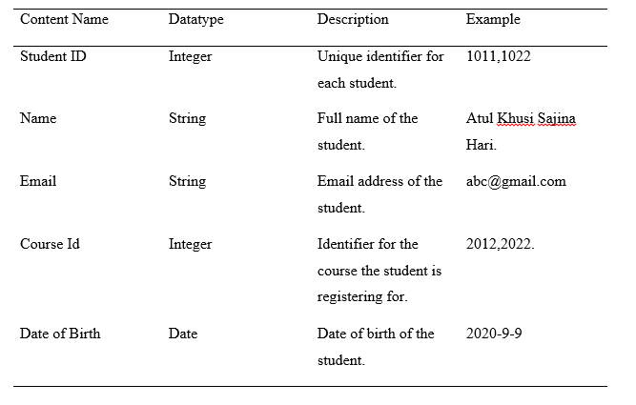

### Component 2: Course

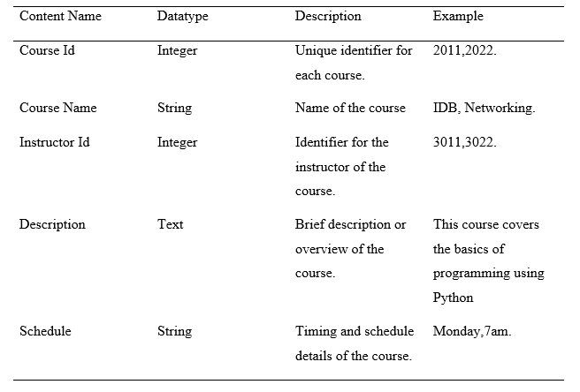

## **6.2 Entity Life History:**

Student. Life history:

When a student creates an account, their information, such as name, email, and date of birth, is stored in the database.

* Enrollment: Students pick courses from the system's accessible list.The system tracks students' progress and performance as they attend classes, submit assignments, and complete evaluations.
* Upon successful completion of a course, the system updates the student's status and they may get a certificate or acknowledgement of completion.
* After finishing a course, students can submit comments on the material, teacher, and overall learning experience, which will be logged in the system.



6.3 UI Deisgn for EDusphere Proconnect

Figure 10 Home Page

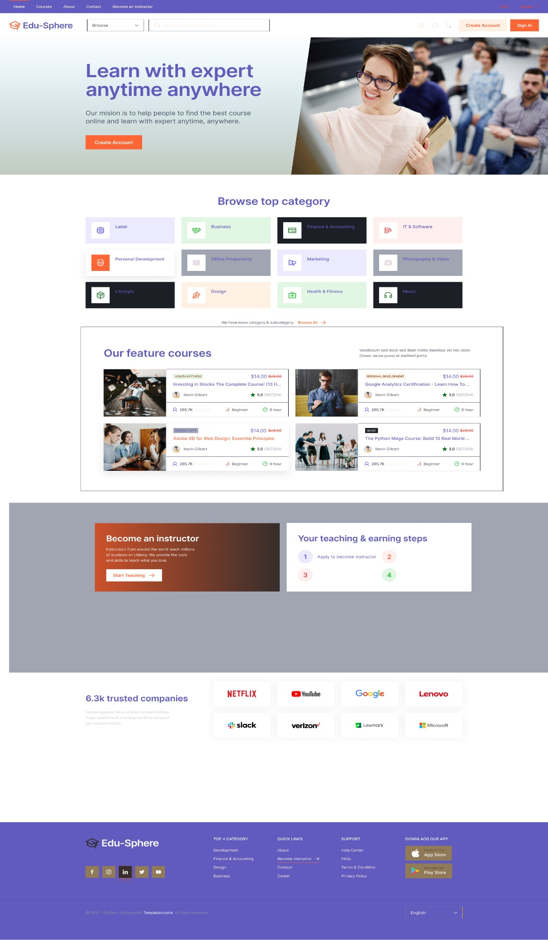

Figure 11 Student Dashboard

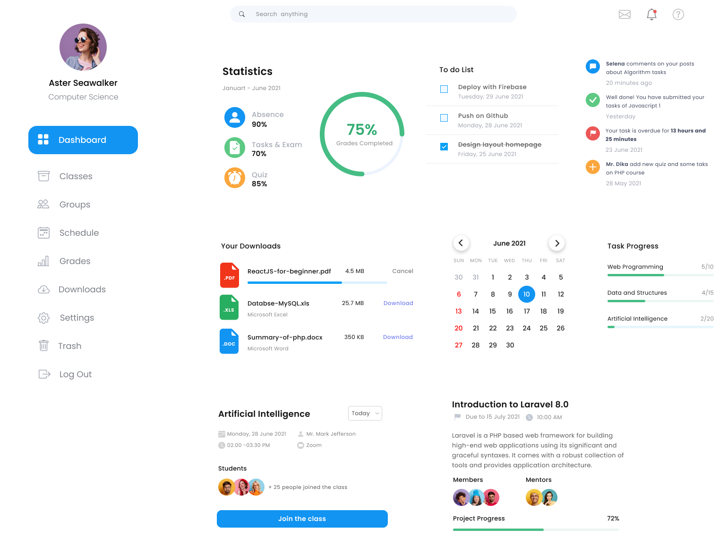

Figure 12Teacher Dashboard

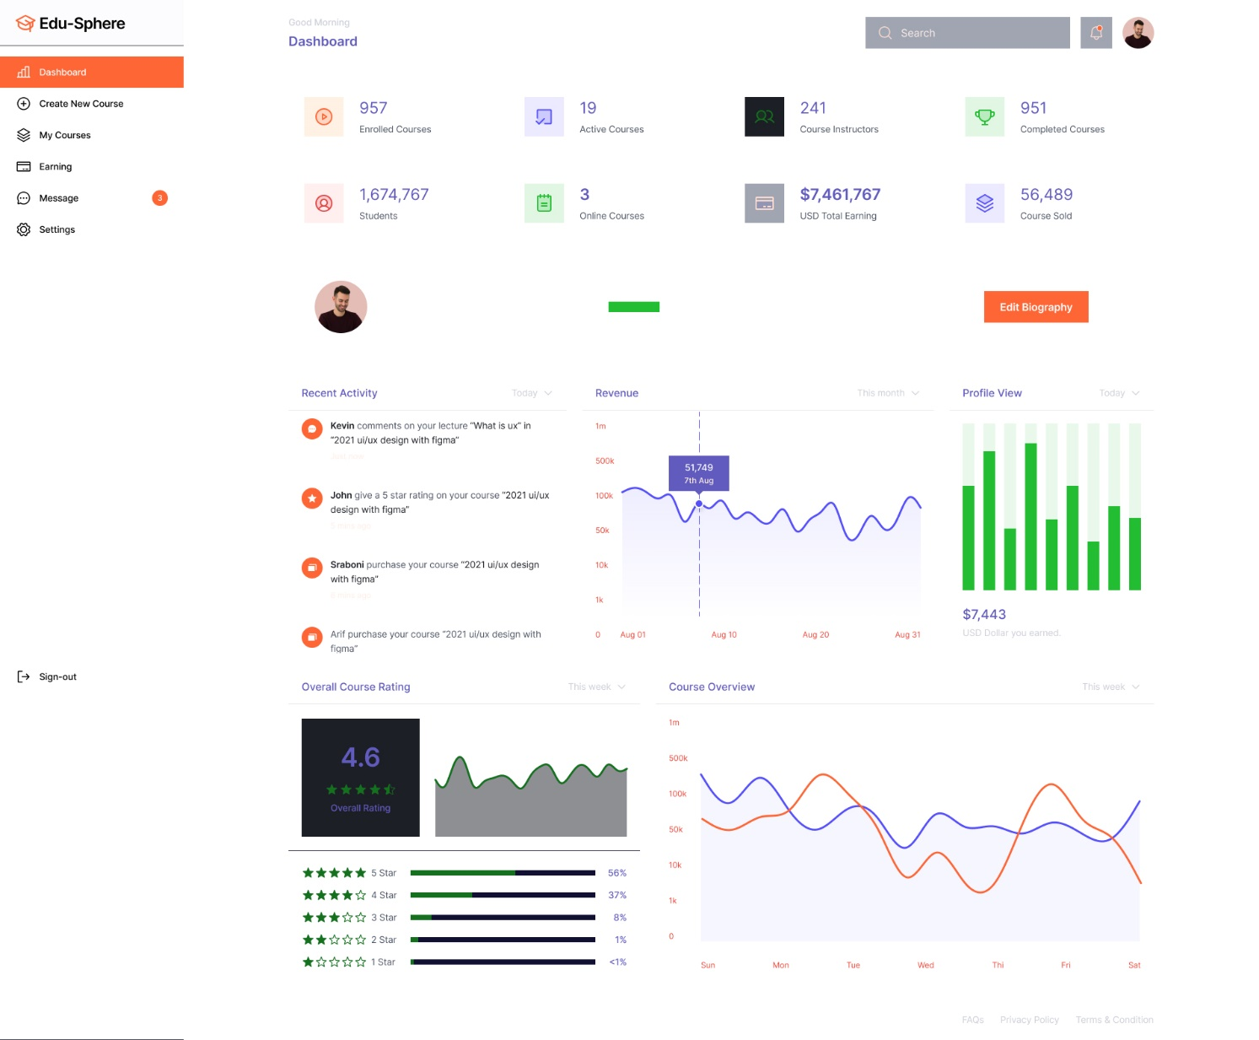

Figure 13 Sign Up Page

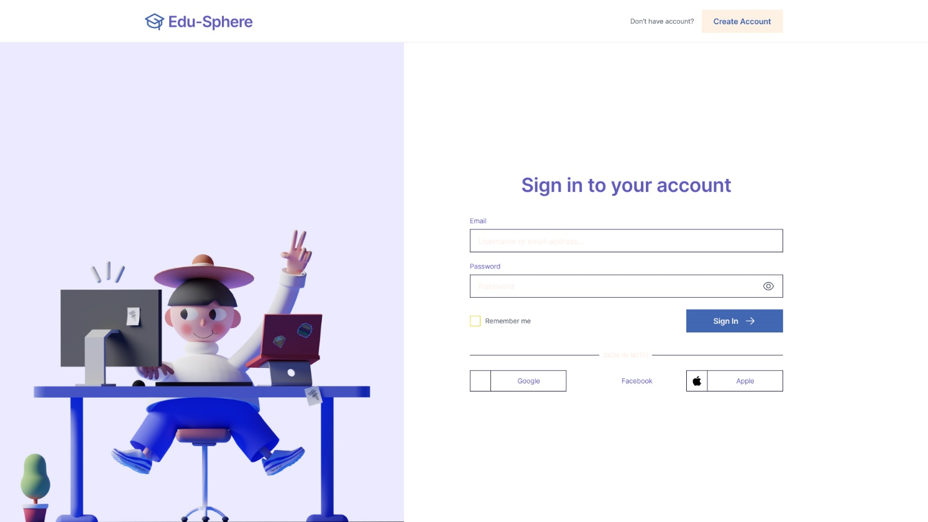

Figure 14 Contact Us page

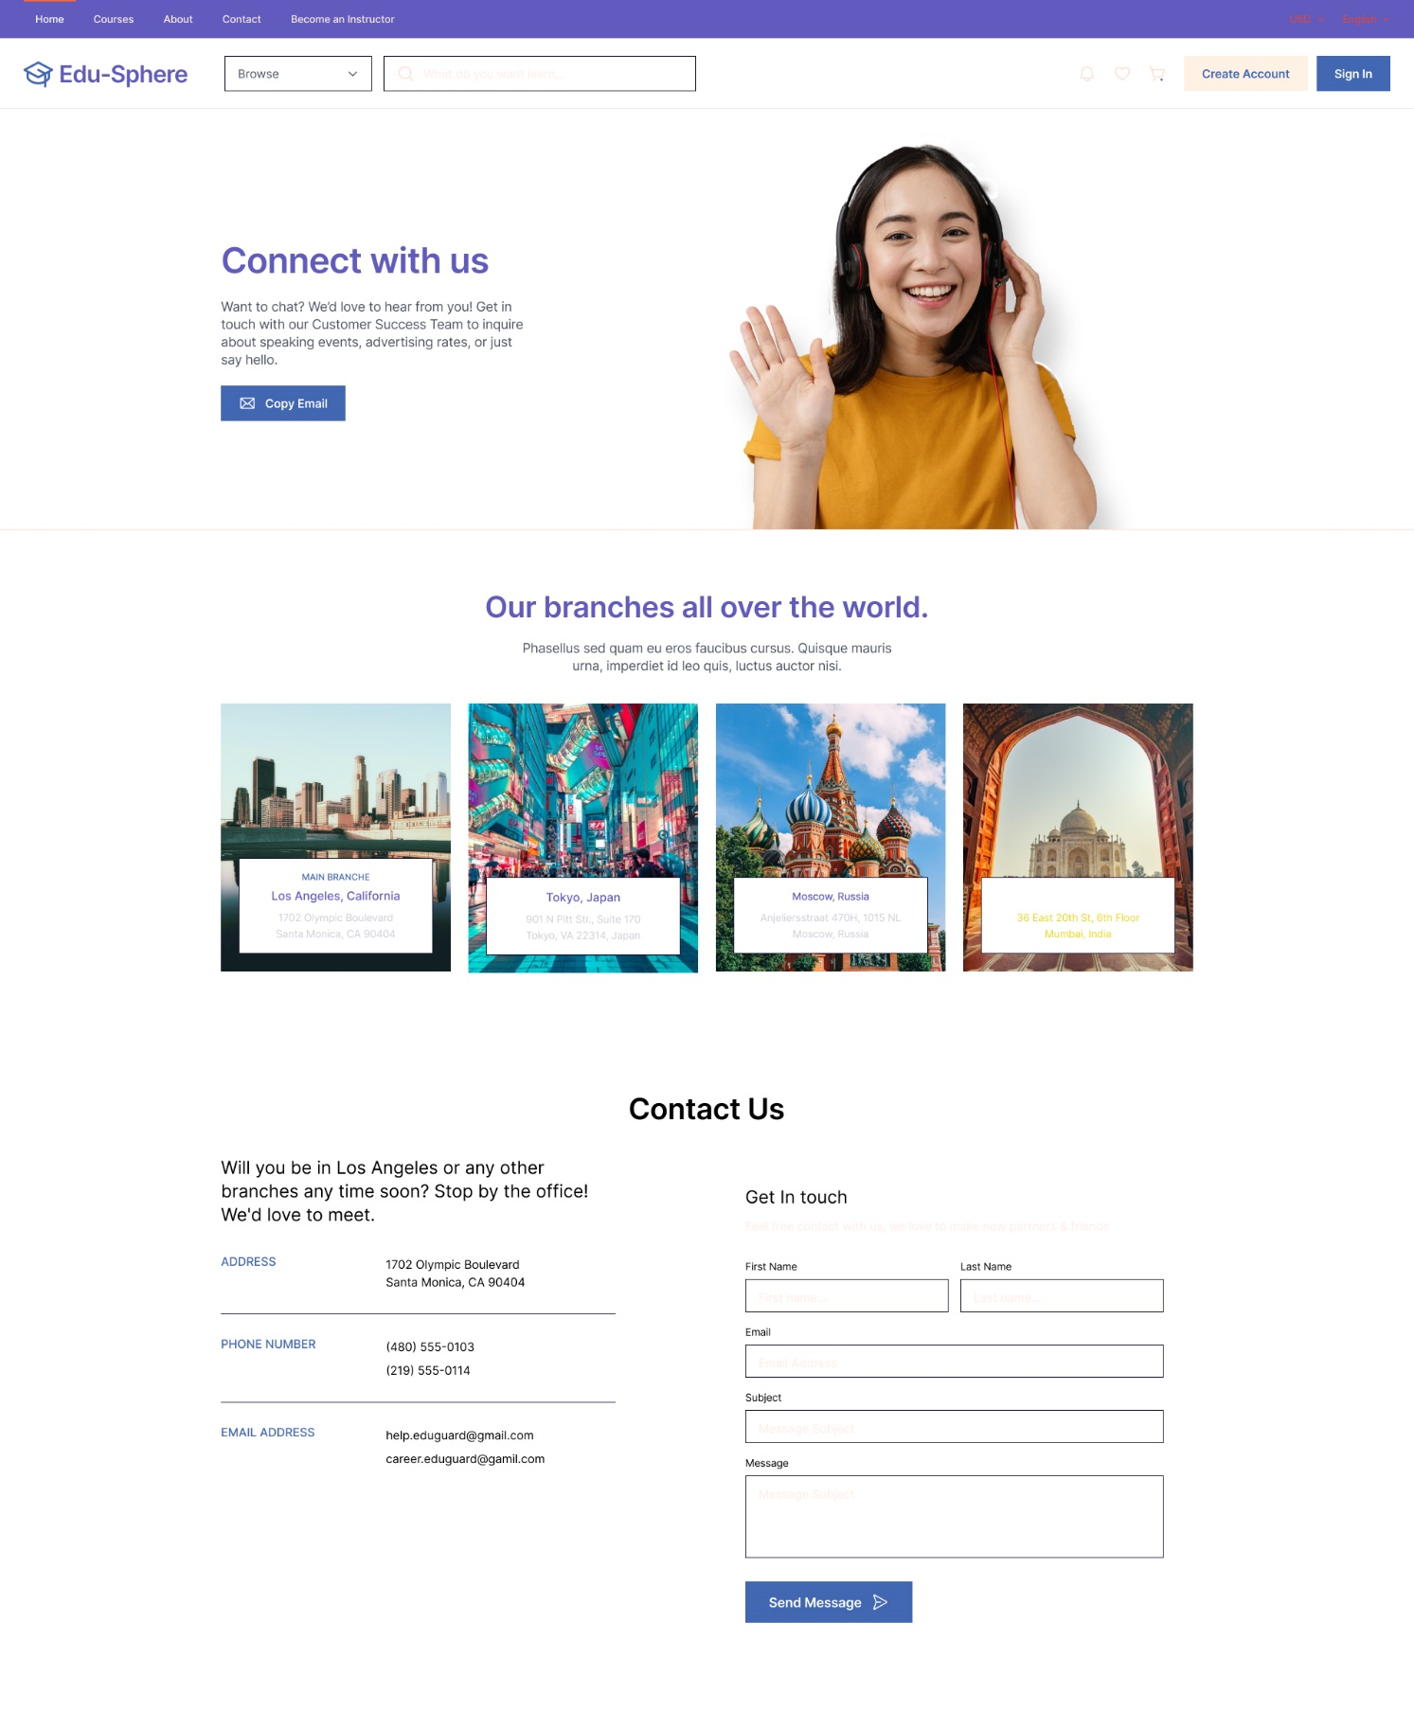

Figure 15 ClassRoom

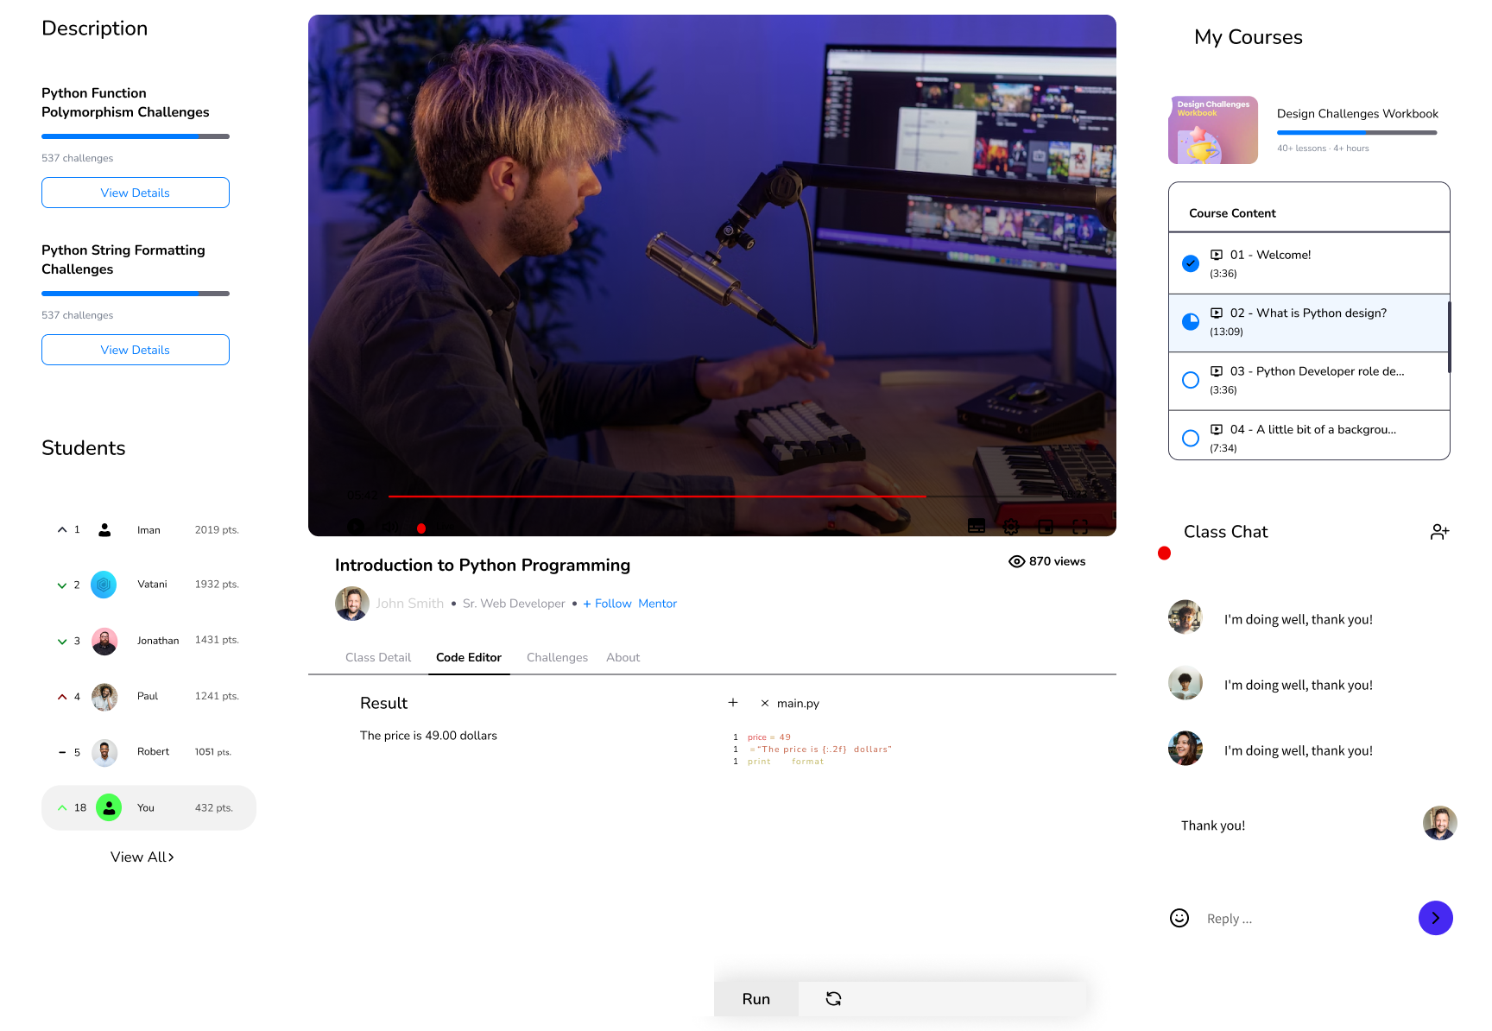

Figure 16 Recorded class



**7. Conclusion**

We appreciate APU University's ambition for "e-learning." As part of our research, we collected and evaluated a large amount of information about learning management systems. We concentrated on issues that fulfilled our assignment criteria. We carefully curated material, including a description of the system's capabilities. We documented the system's aims and current topics.   
  
We built a work matrix and monitored project breakdown to ensure timely completion. Our feasibility research included operational, technological, and economic variables for a full examination. Despite the challenges, we completed the project effectively. We addressed common user issues and provided practical solutions to improve the system's usability.

# 8. References

bartleby. (2023, 03 19). *Effects Of Lack Of Resource Materials For Students*. Retrieved from bartleby: https://www.bartleby.com/essay/Effects-Of-Lack-Of-Resource-Materials-For-PKVCHVEBHEF

bcisnotes. (2020, Feb 20). *PIECES Framework || The Context of System Analysis and Design || Bcis Notes*. Retrieved from bcisnotes: https://bcisnotes.com/thirdsemester/system-analysis-and-design/pieces-framework/

clouddefense.ai. (n.d.).

clouddefense.ai. (n.d.). 7 Phases of System Development Lifecycle. pp. https://www.clouddefense.ai/system-development-life-cycle/.

DeFranzo, S. E. (2023, March 19). *Advantages and Disadvantages of Surveys*. Retrieved from snapsurveys: https://www.snapsurveys.com/blog/advantages-disadvantages-surveys/

elearningindustry. (2023, 03 19). *Lack Of eLearning Materials In Secondary Schools*. Retrieved from elearningindustry: https://elearningindustry.com/lack-of-elearning-materials-secondary-schools#:~:text=Inadequate%20technology%20infrastructure.,Consideration%20of%20eLearning%20policies

https://www.geeksforgeeks.org/. (n.d.). *System Design Tutorial*. Retrieved from System Design Tutorial: https://www.geeksforgeeks.org/system-design-tutorial/

intellectsoft.net. (n.d.). 7 phases of System Development Lifecycle. pp. https://www.intellectsoft.net/blog/what-is-system-development-life-cycle/.

LISBDNETWORK. (2022, February 11). *Information Gathering*. Retrieved from lisedunetwork: https://www.lisedunetwork.com/information-gathering/

Medium. (n.d.). *Document Review Process: Guidelines & Best Practices | by HelpLook | Medium*. Retrieved from Medium: https://medium.com/@HelpLook/document-review-process-guidelines-best-practices-38850b5e9bf6

open. (2023, 03 19). *Purpose of teaching and learning materials*. Retrieved from open: https://www.open.edu/openlearncreate/mod/page/view.php?id=168509#:~:text=Learning%20materials%20can%20significantly%20increase,new%20skill%20gained%20in%20class

Research, M. (2022, June 29). *What Is a Questionnaire and How Is It Used in Research?* Retrieved from cint: https://www.cint.com/blog/what-is-a-questionnaire-and-how-is-it-used-in-research

Simplilearn. (2023, 2 3). *Feasibility Study and Its Importance in Project Management*. Retrieved from Simplilearn: https://www.simplilearn.com/feasibility-study-article

skfdjskdfjs. (n.d.). *sdfsdf*. Retrieved 2014

stackify. (n.d.). *SDLC*. Retrieved from stackify: https://stackify.com/what-is-sdlc/

theteacher.info. (2022). *Entity Life History (ELH)*. Retrieved from theteacher.info: https://theteacher.info/index.php/f453-advanced-theory/3-3-9-databases/notes/382-entity-life-history-elh-notes

wikipedia. (n.d.). observation. p. https://en.wikipedia.org/wiki/Observation.

wikipedia.org. (2017, February). *Systems analysis*. Retrieved from wikipedia.org: https://en.wikipedia.org/wiki/Systems_analysis

xgxdfd. (n.d.). *xxfdxd*. Retrieved 2010